Co1
B. TE10 versus TM11: Using the same WR-90 waveguide at f = 10 GHz, simulates both TE10 and TM11 modes. Determine fc, β and the E/H-field distributions for each mode. Calculate the theoretical cutoff frequencies using fc(mn)=c/2√[(m/a)²+(n/b)²]. Compare the results and justify why TE10 propagates at 10 GHz while TM11 does not.

EXP. 2 — QUESTION B

COMPARISON OF TE10 AND TM11 MODES IN A WR-90 RECTANGULAR WAVEGUIDE

1. AIM
To simulate and compare the TE10 and TM11 modes of a WR-90 rectangular waveguide at 10 GHz using MATLAB. To calculate the theoretical cutoff frequencies and propagation constants, plot the electric and magnetic field distributions, and determine why TE10 propagates while TM11 does not at the specified operating frequency.

2. SOFTWARE USED
MATLAB

3. MATLAB CODE
Insert the MATLAB program used to calculate the cutoff frequencies and propagation constants of the TE10 and TM11 modes and plot their electric and magnetic field distributions.

clc;
clear;
close all;
format short g;

%% TE10 VERSUS TM11 - WR-90 WAVEGUIDE

%% 1. GIVEN PARAMETERS
c = 299792458;
mu0 = 4*pi*1e-7;
eps0 = 1/(mu0*c^2);

a = 22.86e-3;
b = 10.16e-3;
f = 10e9;

omega = 2*pi*f;
k0 = omega/c;

%% 2. CUTOFF FREQUENCIES
fc_TE10 = c/(2*a);
fc_TM11 = (c/2)*sqrt((1/a)^2+(1/b)^2);

%% 3. PROPAGATION AND ATTENUATION
kc_TE10 = pi/a;
kc_TM11 = sqrt((pi/a)^2+(pi/b)^2);

beta_TE10 = sqrt(k0^2-kc_TE10^2);

if f > fc_TM11
beta_TM11 = sqrt(k0^2-kc_TM11^2);
alpha_TM11 = 0;
else
beta_TM11 = 0;
alpha_TM11 = sqrt(kc_TM11^2-k0^2);
end

%% 4. DISPLAY RESULTS
fprintf('\n====================================\n');
fprintf(' TE10 VERSUS TM11 - WR-90\n');
fprintf('====================================\n');
fprintf('Width a = %.2f mm\n',a*1e3);
fprintf('Height b = %.2f mm\n',b*1e3);
fprintf('Frequency = %.3f GHz\n',f/1e9);
fprintf('TE10 cutoff = %.4f GHz\n',fc_TE10/1e9);
fprintf('TM11 cutoff = %.4f GHz\n',fc_TM11/1e9);
fprintf('TE10 beta = %.3f rad/m\n',beta_TE10);
fprintf('TM11 beta = %.3f rad/m\n',beta_TM11);
fprintf('TM11 alpha = %.3f Np/m\n',alpha_TM11);

%% 5. CROSS-SECTION GRID
Nx = 150;
Ny = 80;

x = linspace(0,a,Nx);
y = linspace(0,b,Ny);
[X,Y] = meshgrid(x,y);

X1 = pi*X/a;
Y1 = pi*Y/b;

%% 6. TE10 FIELDS (NORMALIZED)
Ey_TE10 = sin(X1);
Hx_TE10 = sin(X1);
Hz_TE10 = cos(X1);

%% 7. TM11 FIELDS (NORMALIZED)
Ez_TM11 = sin(X1).*sin(Y1);

Ex_TM11 = cos(X1).*sin(Y1);
Ey_TM11 = sin(X1).*cos(Y1);

Hx_TM11 = sin(X1).*cos(Y1);
Hy_TM11 = -cos(X1).*sin(Y1);

Etrans_TM11 = sqrt(Ex_TM11.^2+Ey_TM11.^2);
Htrans_TM11 = sqrt(Hx_TM11.^2+Hy_TM11.^2);

%% 8. PROPAGATION COMPARISON
L = 100e-3;
z = linspace(0,L,400);

E_TE10_z = cos(beta_TE10*z);
E_TM11_z = exp(-alpha_TM11*z);

%% 9. ALL PLOTS IN ONE FIGURE
figure('Color','w',...
'Name','TE10 vs TM11 - All Plots',...
'NumberTitle','off',...
'Position',[50 50 1400 850]);

% Plot 1: TE10 Ey
subplot(3,3,1);
imagesc(x*1e3,y*1e3,Ey_TE10);
set(gca,'YDir','normal');
axis image; colorbar;
xlabel('x (mm)'); ylabel('y (mm)');
title('1. TE10 E_y');

% Plot 2: TE10 Hx
subplot(3,3,2);
imagesc(x*1e3,y*1e3,Hx_TE10);
set(gca,'YDir','normal');
axis image; colorbar;
xlabel('x (mm)'); ylabel('y (mm)');
title('2. TE10 H_x');

% Plot 3: TE10 Hz
subplot(3,3,3);
imagesc(x*1e3,y*1e3,Hz_TE10);
set(gca,'YDir','normal');
axis image; colorbar;
xlabel('x (mm)'); ylabel('y (mm)');
title('3. TE10 H_z');

% Plot 4: TM11 Ez
subplot(3,3,4);
imagesc(x*1e3,y*1e3,Ez_TM11);
set(gca,'YDir','normal');
axis image; colorbar;
xlabel('x (mm)'); ylabel('y (mm)');
title('4. TM11 E_z');

% Plot 5: TM11 transverse E magnitude
subplot(3,3,5);
imagesc(x*1e3,y*1e3,Etrans_TM11);
set(gca,'YDir','normal');
axis image; colorbar;
xlabel('x (mm)'); ylabel('y (mm)');
title('5. TM11 Transverse E');

% Plot 6: TM11 Hx
subplot(3,3,6);
imagesc(x*1e3,y*1e3,Hx_TM11);
set(gca,'YDir','normal');
axis image; colorbar;
xlabel('x (mm)'); ylabel('y (mm)');
title('6. TM11 H_x');

% Plot 7: TM11 Hy
subplot(3,3,7);
imagesc(x*1e3,y*1e3,Hy_TM11);
set(gca,'YDir','normal');
axis image; colorbar;
xlabel('x (mm)'); ylabel('y (mm)');
title('7. TM11 H_y');

% Plot 8: TM11 transverse H magnitude
subplot(3,3,8);
imagesc(x*1e3,y*1e3,Htrans_TM11);
set(gca,'YDir','normal');
axis image; colorbar;
xlabel('x (mm)'); ylabel('y (mm)');
title('8. TM11 Transverse H');

% Plot 9: Propagation comparison
subplot(3,3,9);
plot(z*1e3,E_TE10_z,'b-','LineWidth',1.8);
hold on;
plot(z*1e3,E_TM11_z,'r--','LineWidth',1.8);
grid on;
xlabel('Distance z (mm)');
ylabel('Normalized amplitude');
title('9. Propagation Comparison');
legend('TE10','TM11 decay','Location','best');
hold off;

sgtitle('WR-90 Waveguide: TE10 Versus TM11');

%% 10. RESULTS TABLE
Mode = {'TE10';'TM11'};
Cutoff_GHz = [fc_TE10;fc_TM11]/1e9;
Beta_rad_per_m = [beta_TE10;beta_TM11];
Alpha_Np_per_m = [0;alpha_TM11];

Mode_Status = {'Propagating';'Below cutoff - evanescent'};

Results = table(Mode,Cutoff_GHz,Beta_rad_per_m,...
Alpha_Np_per_m,Mode_Status);

fprintf('\n--- FINAL COMPARISON TABLE ---\n');
disp(Results);

fprintf('\n--- CONCLUSION ---\n');
fprintf('TE10 propagates at 10 GHz.\n');
fprintf('TM11 is below cutoff at 10 GHz.\n');
fprintf('All nine plots are displayed in one figure.\n');

4. OUTPUT
Insert the MATLAB output screenshots showing:
- TE10 electric-field distribution.
- TE10 magnetic-field distribution.
- TM11 electric-field distribution.
- TM11 magnetic-field distribution.
- Cutoff frequencies and propagation characteristics of both modes.
Theoretical calculations:
Given:
a = 22.86 × 10⁻³ m
b = 10.16 × 10⁻³ m
f = 10 GHz
c = 3 × 10⁸ m/s
Cutoff frequency:
fc(mn) = (c/2)√[(m/a)² + (n/b)²]
For TE10 (m = 1, n = 0):
fc₁₀ = (c/2a) ≈ 6.562 GHz
Since 10 GHz > 6.562 GHz, TE10 propagates.
Propagation constant:
β₁₀ = (2πf/c)√[1 − (fc₁₀/f)²]
β₁₀ ≈ 158.05 rad/m
For TM11 (m = 1, n = 1):
fc₁₁ = (c/2)√[(1/a)² + (1/b)²]
fc₁₁ ≈ 16.15 GHz
Since 10 GHz < 16.15 GHz, TM11 is below cutoff and does not propagate. Its propagation constant is imaginary in the ideal lossless waveguide, corresponding to an evanescent field.

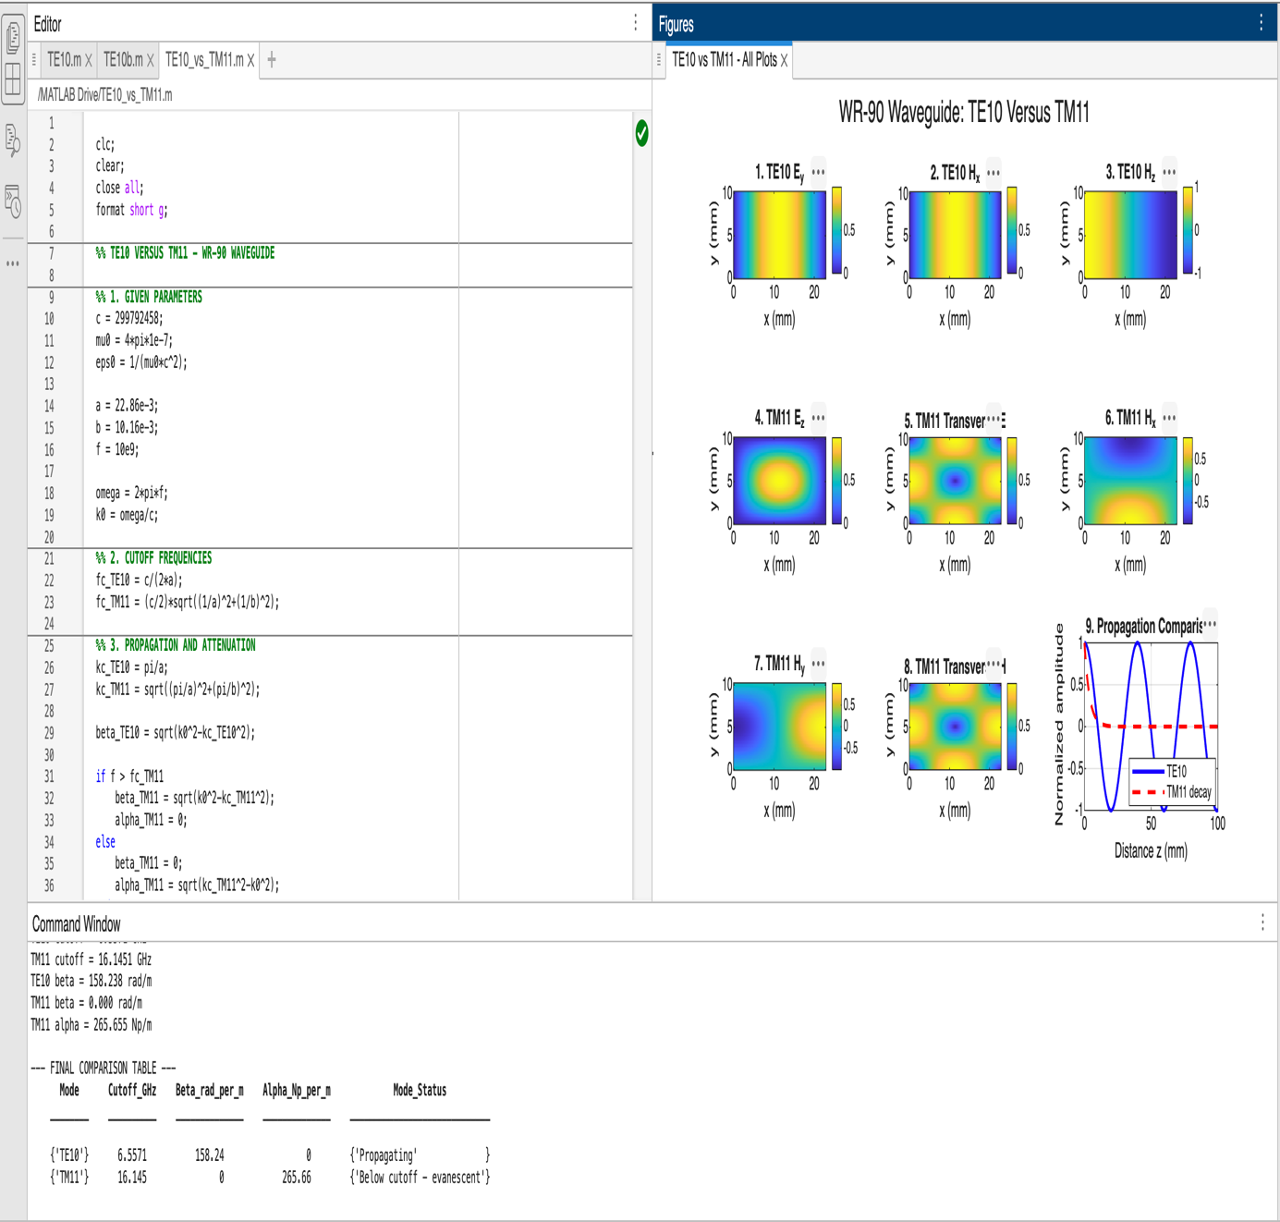

5. RESULT
The TE10 and TM11 modes of the WR-90 rectangular waveguide were analyzed using MATLAB. The theoretical cutoff frequencies were found to be approximately 6.562 GHz for TE10 and 16.15 GHz for TM11. Therefore, at 10 GHz, TE10 propagates because the operating frequency exceeds its cutoff frequency, whereas TM11 is below cutoff and decays exponentially along the waveguide.

